**Argo CD**

**Argo CD Architecture**

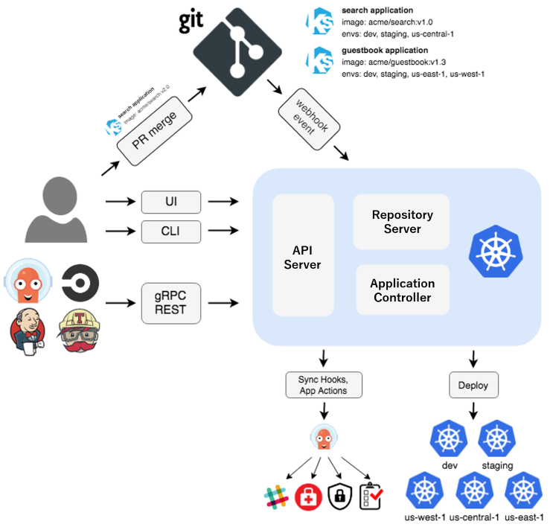

**Argo CD Installation**

Requirements

* Install [kubectl](https://kubernetes.io/docs/tasks/tools/install-kubectl/) command-line tool:
  + [Install and Set Up kubectl on Linux | Kubernetes](https://kubernetes.io/docs/tasks/tools/install-kubectl-linux/)
* Have a [kubeconfig](https://kubernetes.io/docs/tasks/access-application-cluster/configure-access-multiple-clusters/) file (default location is ~/.kube/config):
  + cd /.kube/config 🡪 Check kubeconfig file is present.

1. Install Argo CD

* *kubectl create namespace argocd*
* *kubectl apply -n argocd -f* [*https://raw.githubusercontent.com/argoproj/argo-cd/stable/manifests/install.yaml*](https://raw.githubusercontent.com/argoproj/argo-cd/stable/manifests/install.yaml)

1. Download Argo CD CLI

For Linux using Curl:

* *curl -sSL -o argocd-linux-amd64* [*https://github.com/argoproj/argo-cd/releases/latest/download/argocd-linux-amd64*](https://github.com/argoproj/argo-cd/releases/latest/download/argocd-linux-amd64)

1. Access The Argo CD API Server

Change the argocd-server service type to LoadBalancer:

* *kubectl patch svc argocd-server -n argocd -p '{"spec": {"type": "LoadBalancer"}}'*
* *kubectl get all -argocd* 🡪 Access it with the IP address.

1. Username and Password (Login Using The CLI)

* Username - admin
* For password,
  + *argocd admin initial-password -n argocd* 🡪 Copy the password.

1. To change default password:

Login to Argo CD's IP or hostname:

* argocd login <ARGOCD_IP_address> 🡪Enter username, default password.
* argocd account update-password 🡪 To update password.